**MACHINE LEARNING TECHNIQUES FOR CYBER ATTACKS DETECTION**

**Software requirements**

**• Programming Language : Python, Jupyter Notebook**

**• Packages : Numpy,Matplotlib,SKlearn, Pandas, Flask**

**• Tool : Python 3.7**

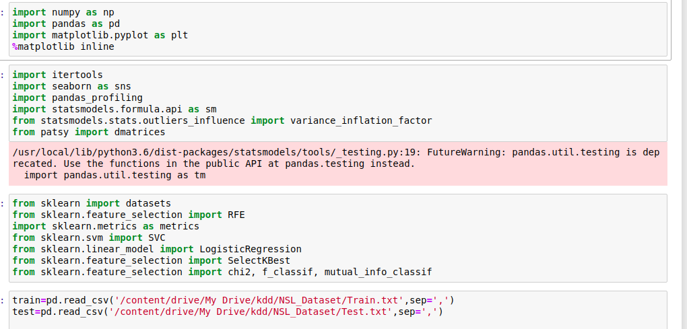

**Data preprocessing**

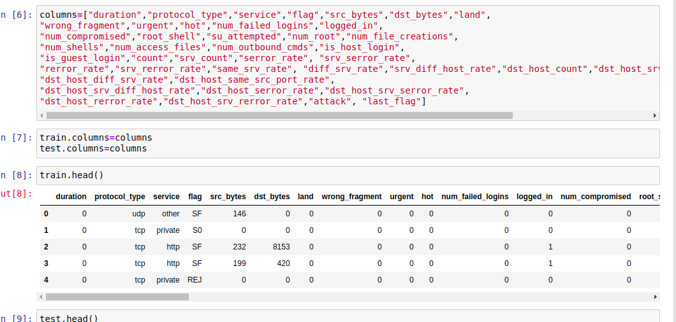

**Data EDA**

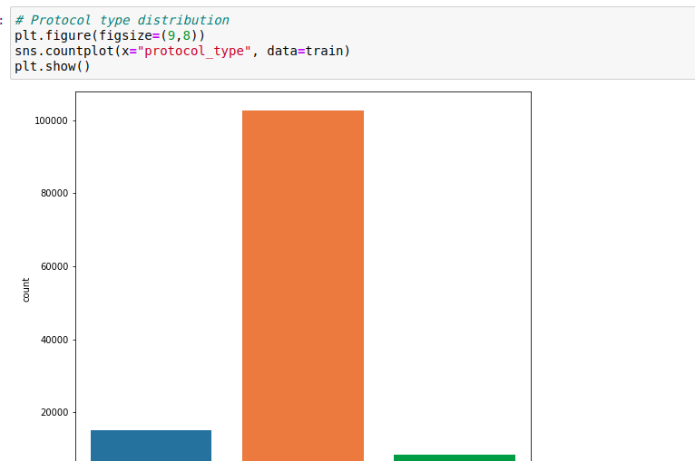

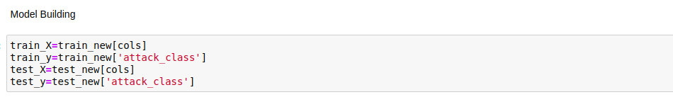

**ML Deploy**

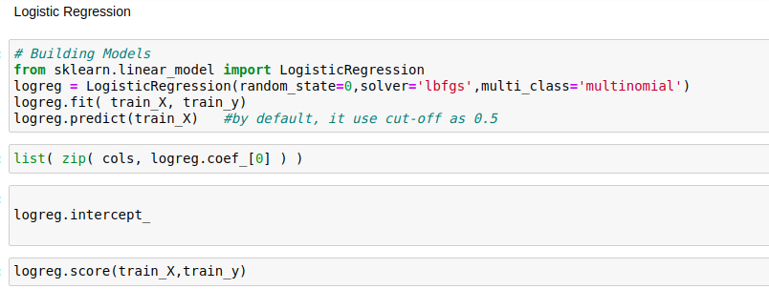

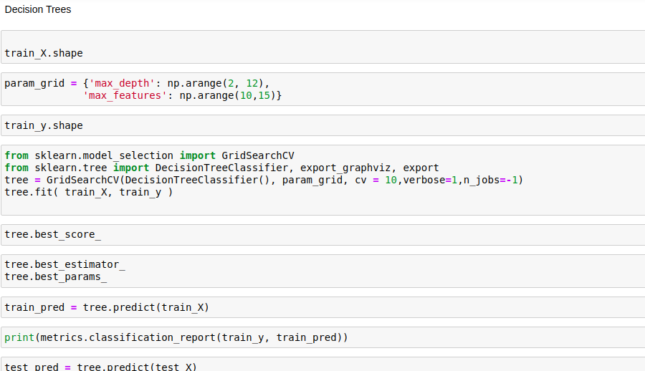

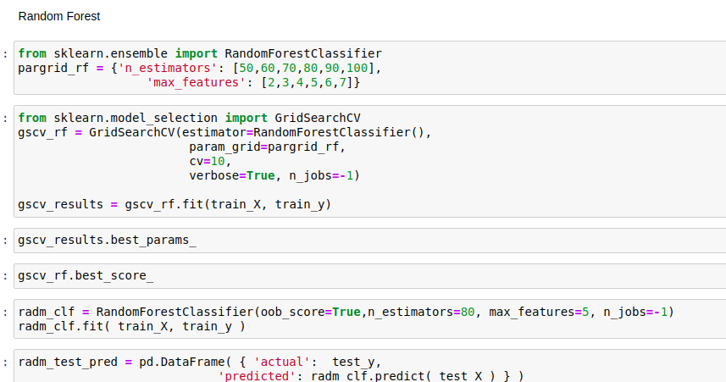

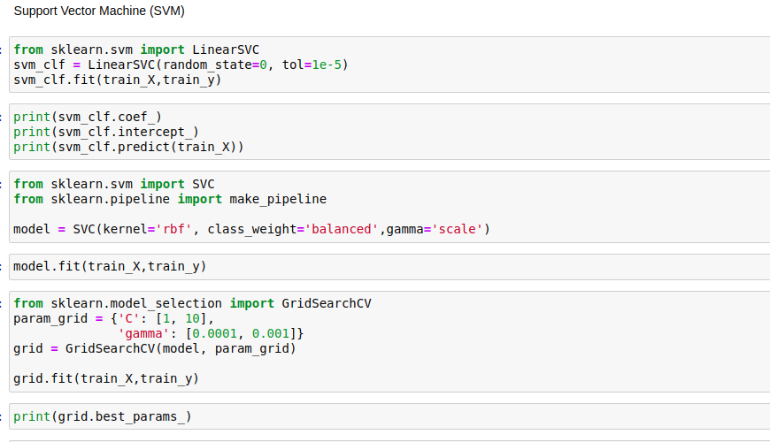

**From the score accuracy we concluding the DT & RF give better accuracy and building pickle file for predicting the user input**

**Application**

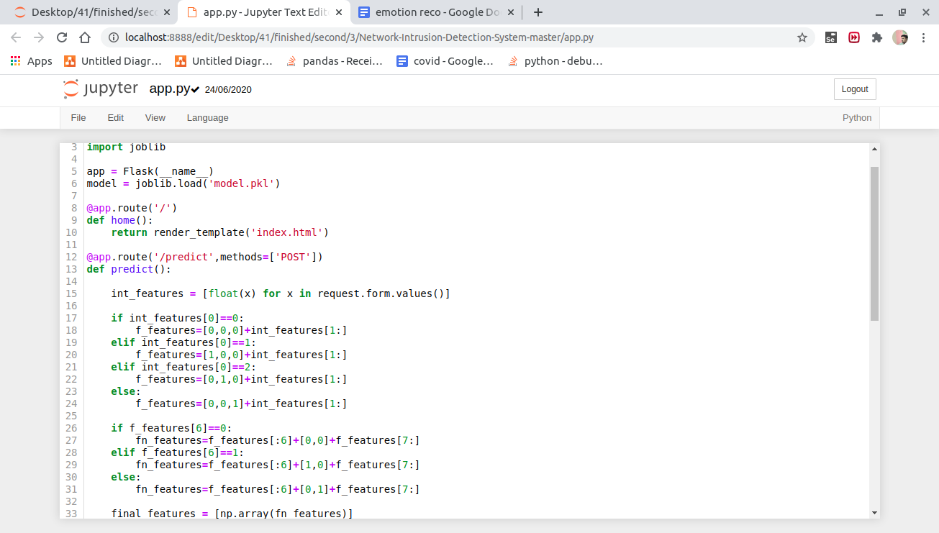

**Localhost - in cmd python app.py**

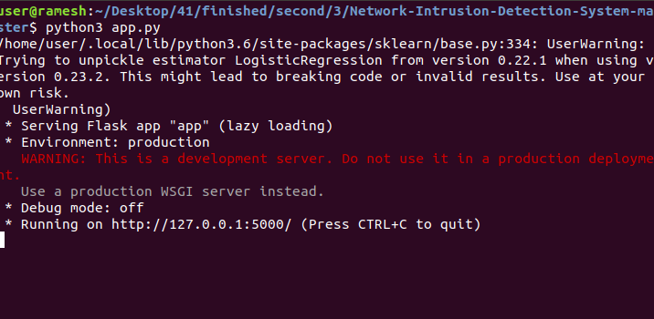

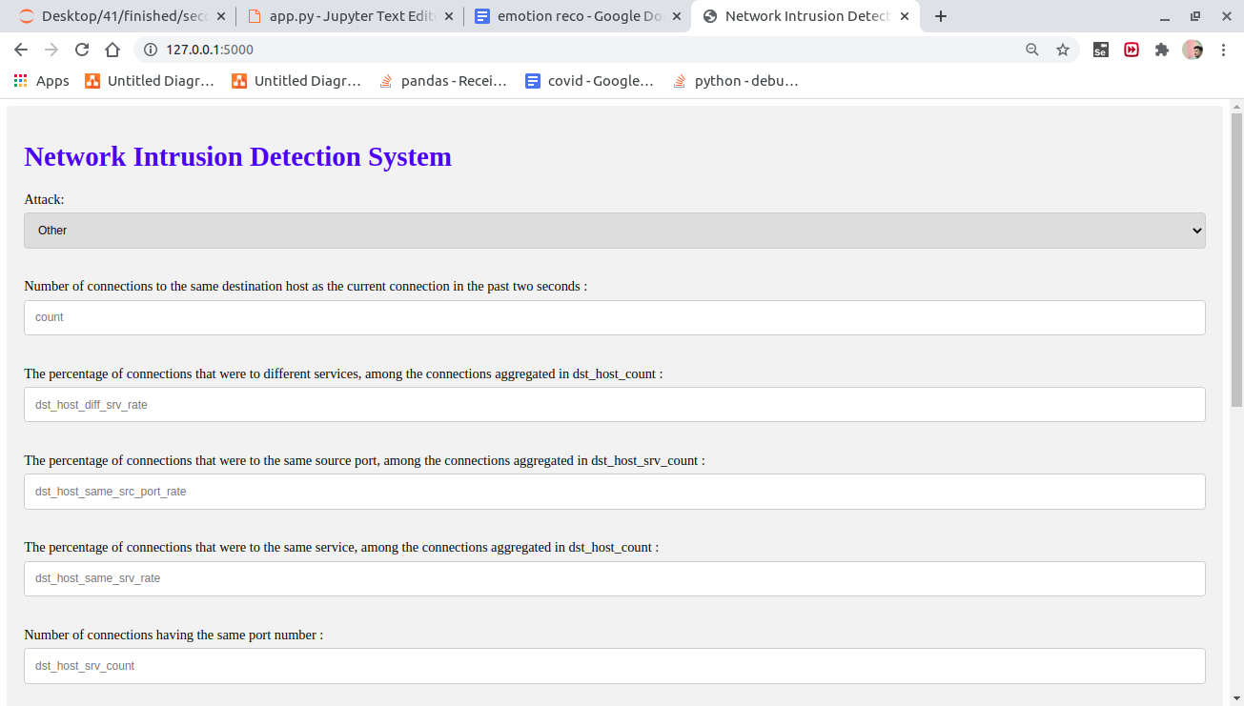

**Enter the input**

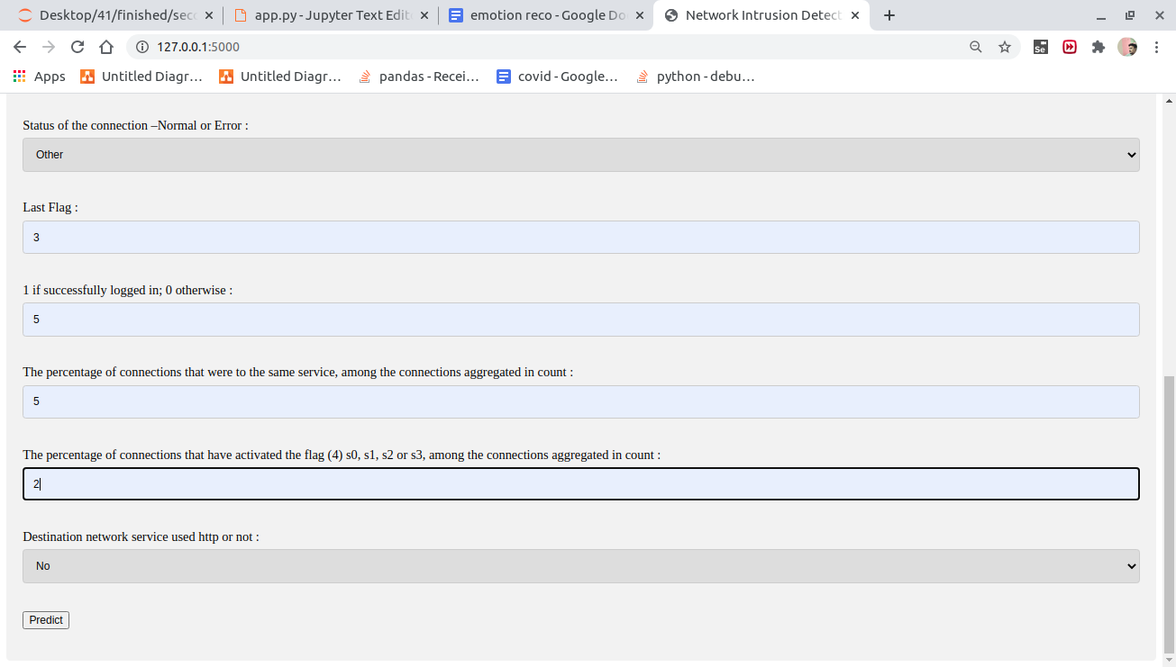

**Predict attack -** 